QC/ALM Project Configure tool

Contents

Overview 1

Configuration file 2

Actions.csv File 4

File Use and Formatting 4

Syntax Notes 4

Syntax 5

<Template> Parameter 5

<Action> Parameter 5

GroupPermissionRemove OR GroupPermissionAdd 5

Development Notes 6

Setting Group Permissions 6

SP2 Read Me 6

ICustomizationPermissions 11

ICustomizationAction Interface 12

Actions Table 12

# Overview

This document describes the QCUpgradePostProcessing tool for QC/ALM. This tool is executed on projects that have been migrated from a QC10 server to an ALM11 server.

The tool is a command line, so that it can easily be integrated in any automated process.

High level features:

* Follow a text based script (CSV format) to configure QC/ALM projects
* Patch QC/ALM workflow code
* Add or remove group permissions
* Change field customization

This Visual Basic .Net solution was originally created for the QC9.2 to QC10 upgrade. It has been modified for the migration from QC10 to ALM11 – all versions, from QC 9.2, should be working.

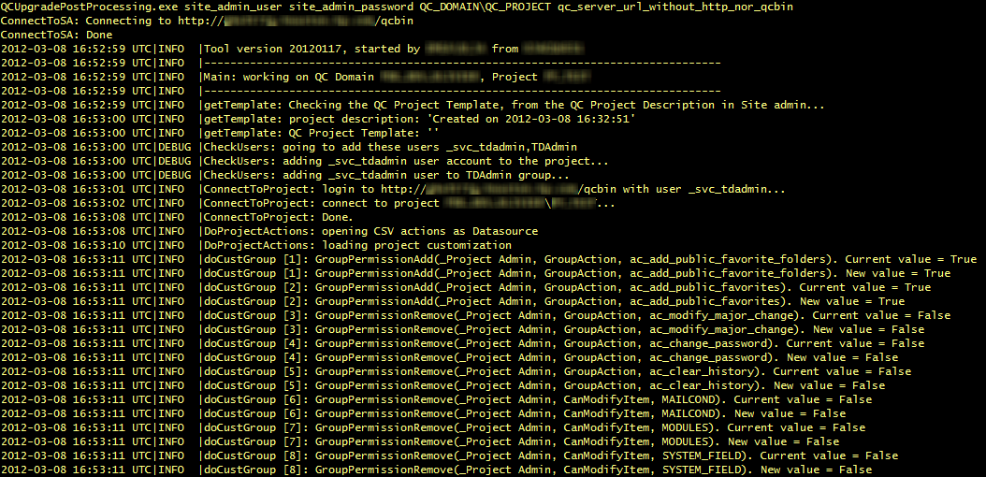

# Configuration file

The QCUpgradePostProcessing.exe.config must be modified for the tool to work properly. The various parameters are:

- **TDAdminUser**: User which must exist in site admin: this user will be added to the project in TDAdmin group, and is used to connect to the project and implement the changes

- **TDAdminPassword**: the password of the above user

- **QCTemplateGroups**: used to determine if the group is a group which is standard across projects (see “Actions.csv File” section).

- **QCDefaultGroups**: used to determine if the group is a system group.

- **QCFarm (optional)**: QC/ALM server URL. Can be override through command line

- **SaveLogsTo (optional)**: location where logs can be saved/backed up

- **ProjectUsersWithGroup** **(optional)**: those users will be added to the projects, in the group specified. Format is “UserName1,GroupName1,UserName2,GroupName2”

- **ManagedTemplates**: Project templates which will match “ALLSTD” in actions.csv.

- **EmailActivated (optional)**: yes: sends email in case of error

- **EmailFrom (optional)**: From email address used when sending email in case of error

- **EmailTo (optional)**: To email address used when sending email in case of error

- **EmailHost (optional)**: SMTP host used when sending email in case of error

Example:

<applicationSettings>

<QCUpgradePostProcessing.My.MySettings>

<setting name="TDAdminUser" serializeAs="String">

<value>CHANGE_ME_TDAdmin_User_Name</value>

</setting>

<setting name="TDAdminPassword" serializeAs="String">

<value>CHANGE_ME_TDAdmin_User_Password</value>

</setting>

<setting name="QCTemplateGroups" serializeAs="String">

<value>CHANGE_ME__Engineer,_Lead,_Product Definer,_Project Admin,_Reporter,_Test Definer,_Test Executor,_Project Manager</value>

</setting>

<setting name="QCDefaultGroups" serializeAs="String">

<value>Developer,Project Manager,QATester,TDAdmin,Viewer</value>

</setting>

<setting name="QCFarm" serializeAs="String">

<value />

</setting>

<setting name="SaveLogsTo" serializeAs="String">

<value />

</setting>

<setting name="ProjectUsersWithGroup" serializeAs="String">

<value>CHANGE_ME_alm_user1,alm_group1,alm_user2,alm_group2</value>

</setting>

<setting name="ManagedTemplates" serializeAs="String">

<value>CHANGE_ME_TEMPLATE1,TEMPLATE2</value>

</setting>

<setting name="EmailFrom" serializeAs="String">

<value>from@me.com</value>

</setting>

<setting name="EmailTo" serializeAs="String">

<value>to@you.com</value>

</setting>

<setting name="EmailActivated" serializeAs="String">

<value>no</value>

</setting>

<setting name="EmailHost" serializeAs="String">

<value>smtphost</value>

</setting>

</QCUpgradePostProcessing.My.MySettings>

</applicationSettings>

# Actions.csv File

## File Use and Formatting

Actions.csv is the “script” that is read by the tool and executed. There is one command per line, and it follows a CSV syntax.

The routine that parses actions.csv is DoProjectActions(). This routine expects a comma delimited file with 6 values per line.

As each line in actions.csv is read, the values are passed to the doCustAction() routine.

For purposes of this section the 6 possible columns or fields will be referred to as

<Template>,<Action>,<Param1>,<Param2>,<Param3>,<Param4>

Here is an example of one line:

ALL,GroupPermissionAdd,.Team HP,GroupAction,ac_move_folder,

Note, this particular action does not require <Param4> but a comma is still needed at the end.

## Syntax Notes

* There must be 6 values per line separated by commas.
* Some actions only required 5 values. In that case end the line with a comma. The code will still attempt to read 6 values. Example:

ALL,GroupPermissionAdd,.Team HP,CanAddItem,DESSTEPS,

* The last line must be terminated with a CR/LF. Failure to do so will result in an error. This example in Notepad++ shows the last line is not terminated correctly:

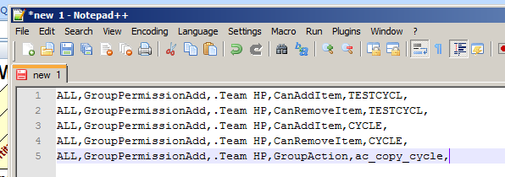

It should look like this:

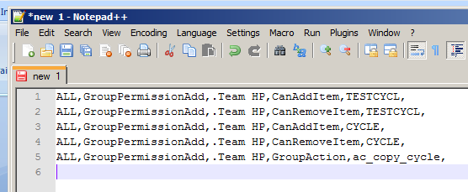

## Syntax

<Template>,<Action>,<Param1>,<Param2>,<Param3>,<Param4>

## <Template> Parameter

Contains a value that describes the “template” or QC master that the remaining values in the row refer to.

Note: Many variable names and comments in the code use the word “template”. This is not to be confused with a CPC (QC10’s “Cross Project Customization” template. “template” in this project refers to a “master” QC project from which projects were created. Keep this in mind when reviewing the code.

This table lists valid values and notes for the first value:

|  |  |
| --- | --- |
| **Value** | **Notes** |
| ALLSTD | Operates on all projects based on known QC masters (defined by “ManagedTemplates” config item) |
| ALL | Operates on all projects |
| <QC Master Name> | A specific QC master Operates only on projects based on this master |

## <Action> Parameter

### GroupPermissionRemove OR GroupPermissionAdd

This action adds or removes the ability to execute actions by members of specific group(s).

<Param1>

|  |  |
| --- | --- |
| **Value** | **Description** |
| ___other___ | Operates on all groups other than the one in “QCTemplateGroups” config item or system “QCDefaultGroups” config item |
| Starts with “!” | Value is a regular expression |
| <group name> | value is the name of a single group |

<Param2>

|  |  |
| --- | --- |
| **Value** | **Description** |
|  |  |
|  |  |
|  |  |
|  |  |
|  |  |

<Param3>

|  |  |
| --- | --- |
| **Value** | **Description** |
|  |  |

<Param4>

|  |  |
| --- | --- |
| **Value** | **Description** |
| No Value needed |  |

# Development Notes

## Setting Group Permissions

### SP2 Read Me

The following info was obtained from the Appendix in the ALM 11 SP2 Readme doc.

In OTA there are functions in two interfaces: ICustomziationPermissions, iCustomizationAction

In ICustomizationAction the methods “AddGroup” and “RemoveGroup” were dropped, and are now restored.

In ICustomizationPermissions the functions are paired, there are functions for getting data and functions for setting data. Only the set functions for the following interfaces were dropped (and they are now restored):

CanAddItem, CanAllowAttachment, CanModifyField, CanModifyItem, CanRemoveItem

Many actions were dropped, actions that were used just for granting normal permissions to everyday items. Using them will not change anything functionally.

When you wanted to give the users of a group the permissions to add new defects you went and took the relevant action “ac_add_bug”, you used the interface AddGroup() to add the group you wanted to give permissions.  
Now, you would just use the CanAddItem setter function, for BUG.  
see an example of this in the script conversion part below.

But there are a lot of actions that were changed, not just BUG:

|  |  |
| --- | --- |
| Name of entity for new interface | Name of action from old interface |
| REQ_TRACE | ac_add_req_trace,  ac_delete_req_trace,  ac_modify_req_trace |
| REQ | ac_add_req,  ac_delete_req,  ac_modify_req |
| BUG | ac_add_bug,  ac_delete_bug,  ac_modify_bug |
| COMPONENT | ac_add_component,  ac_delete_component,  ac_modify_component |
| HOST_GROUP | ac_add_host_group,  ac_delete_host_group,  ac_modify_host_group |
| COMPONENT_FOLDER | ac_add_componentfolder, ac_delete_componentfolder, ac_modify_componentfolder |
| COMPONENT_STEP | ac_add_componentstep, ac_delete_componentstep,  ac_modify_componentstep |
| HOSTS | ac_add_hosts,  ac_delete_hosts,  ac_modify_hosts |
| RUN | ac_delete_run,  ac_modify_run    note: no ac_create_run?? |
| TEST | ac_add_test,  ac_delete_test,  ac_modify_test |
| CYCLE | ac_add_cycle,  ac_delete_cycle,  ac_modify_cycle |
| CYCL_FOLD | ac_add_cyclefolder,  ac_delete_cyclefolder,   ac_modify_cyclefolder |
| DESSTEPS | ac_add_desstep,  ac_delete_desstep,  ac_modify_desstep |
| ALL_LISTS | ac_add_folder,  ac_delete_folder,  ac_modify_folder |
| LIBRARIES | ac_add_library,  ac_delete_library,  ac_modify_library |
| LIBRARY_FOLDERS | ac_add_library_folder,  ac_delete_library_folder, ac_modify_library_folder |
| LINK | ac_add_association,  ac_delete_association,   ac_modify_association |
| RELEASES | ac_add_release,  ac_delete_release,  ac_modify_release |
| RELEASE_CYCLES | ac_add_release_cycle,  ac_delete_release_cycle,  ac_modify_release_cycle |
| FRAMEWORK_PARAM | ac_add_componentparam, ac_delete_componentparam, ac_modify_componentparam |
| RELEASE_FOLDERS | ac_add_release_folder,  ac_delete_release_folder,  ac_modify_release_folder |
| RESOURCES | ac_add_res,  ac_delete_res,  ac_modify_res |
| RESOURCE_FOLDERS | ac_add_resfolder,  ac_delete_resfolder,  ac_modify_resfolder |
| RESULTS | ac_add_result,  ac_delete_result    note: there’s something about this not being documented, possibly removed in developers comments. Ignore this if these actions don’t exist in Quality Center 10.0 docs.    also, no ac_modify_result..? |
| TESTCYCL | ac_add_test_to_testcycl,  ac_delete_test_from_testcycl,  ac_modify_test_in_testcycl |
| TEST_PARAMS | ac_add_testparam,  ac_delete_testparam,  ac_modify_testparam |
| BASELINES | ac_delete_baseline,  ac_modify_baseline    note: no ac_create_baseline?? |

Note that it is tempting to try a naming convention, a simple algorithm to convert from the old name to the new one - but it works for only about half of the names... Names that don’t work are marked in red.  
Suggest against using this approach.

Below is how to transform an old script, from say, Quality 10.0 to something that will work in ALM11.0 and beyond.

*Script conversion:*

*‘connect to server*

*Set conn = CreateObject("TDAPIOLE80.TDConnection.1")*

*conn.InitConnectionEx "http://vmqcqa08.devlab.ad:8080/qcbin"*

*conn.Login "sa", ""*

*conn.Connect "DEFAULT", "nathanproject"*

*MsgBox "connected to Quality Center 10.0"*

*Dim custom*

*Dim action*

*Set custom = conn.Customization*

*custom.Load*

*‘add permissions for NathanOtaTestGroup to create bugs*

*Set action = custom.Actions.Action("ac_add_bug")*

*action.AddGroup("NathanOtaTestGroup")*

*custom.Commit*

*custom.Load*

*conn.DisconnectProject*

*conn.Logout*

*conn.ReleaseConnection*

*MsgBox "disconnected from Quality Center 10.0"*

Turns into:

*Set conn = CreateObject("TDAPIOLE80.TDConnection.1")*

*conn.InitConnectionEx "http://vmqcrnd50.devlab.ad:8081/qcbin"*

*conn.Login "sa", ""*

*conn.Connect "DEFAULT", "nathanproject"*

*MsgBox "Connected!"*

*Dim custom*

*Dim customPermissions*

*Set custom = conn.Customization*

*custom.Load*

*‘note tagTDAPI_GRANT_MODIFY.GRANT_MODIFY_PERMITtagTDAPI_GRANT_MODIFY.GRANT_MODIFY_ tagTDAPI_GRANT_MODIFY.GRANT_MODIFY_ = 0*

*Set customPermissions = custom.Permissions*

*customPermissions.CanAddItem("BUG", "NathanOtaTestGroup") = 0*

*custom.Commit*

*custom.Load*

*conn.DisconnectProject*

*conn.Logout*

*conn.ReleaseConnection*

*MsgBox "Disconnected!"*

Testing:

To test this and map exactly what worked in Quality Center 10.0 to what works in ALM 11.0 with the new interface you will need two servers.

First, concerning the “catch” – the actions that were dropped and are now executed via new interface:

For the Quality Center 10.0 server, try and grant permissions via the old interface, and see that it works by actually attempting the operation (i.e. add a bug), then remove it and try the operation again (and fail).

Then try granting the permissions with the new interface to the ALM 11.0 server. The functionalities should match.

Use a mapping that matches the above table to get the name of the entity from the name of the action.

See the above script for an example on how to use the new interface, and how to use the old one.

Second, use all functions in the restored api (mentioned above, ICustomizationPermissions/ICustomizationAction), and see that functionality matches set permissions.

It is best to do this generically for each type of entity, but a test on a specific entity is also an ok indicator (though that’s what we did here manually in dev, so there’s not much extra value in that..).

Summary:

The docs should copy paste the content of Quality Center 10.0 as far as ICustomizationPermissions and ICustomizationAction excluding and explicity stating the difference with above mentioned actions, and how to execute them correctly, according to the new api.

## ICustomizationPermissions

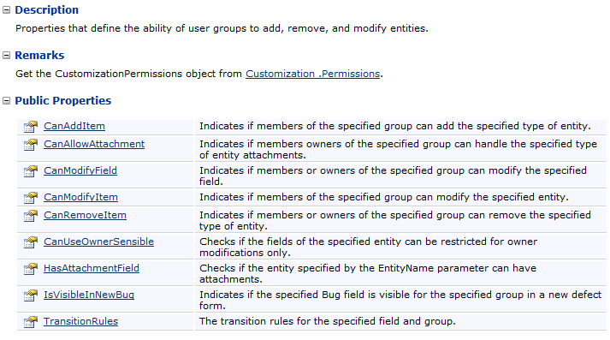

## ICustomizationAction Interface

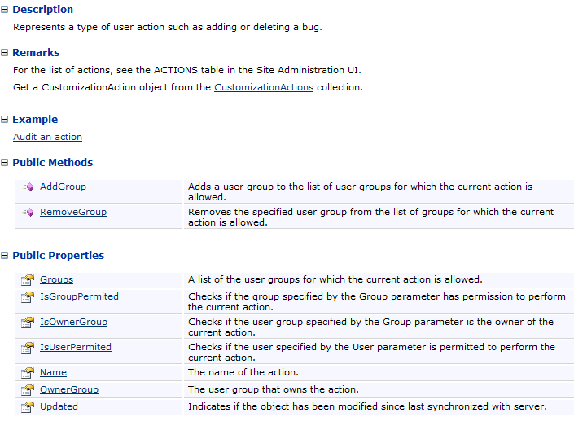

### Actions Table

|  |  |  |
| --- | --- | --- |
| AC_ACTION_NAME | AC_OPERATION_NAME | AC_ENTITY_NAME |
| ac_QPM_Category | QPMCategory |  |
| ac_add_AnalysisFolders_public | Create | analysis-item-folder |
| ac_add_DashboardFolders_public | Create | dashboard-folder |
| ac_add_DashboardPage_public | Create_public | dashboard-page |
| ac_add_ExcelReport_public | Create_excel_report_public | analysis-item |
| ac_add_Graph_public | Create_graph_public | analysis-item |
| ac_add_StandardReport_public | Create_standard_report_public | analysis-item |
| ac_add_TemplateReport_public | Create_template_report_public | analysis-item |
| ac_add_public_favorite_folders | Create_public | favorite-folder |
| ac_add_public_favorites | Create_public | favorite |
| ac_add_r&d_comments | Should be hidden ;) | defect |
| ac_add_reqfolder | Operation_ac_add_reqfolder |  |
| ac_audit_trail_customization | Customize_audit_trail |  |
| ac_capture_baseline | Capture | baseline |
| ac_change_password | Change_password |  |
| ac_clear_history | Clear_history |  |
| ac_compare | Comparison | library |
| ac_configure_mail | Configure_mail |  |
| ac_copy_cycle | Copy | test-set |
| ac_copy_cyclefolder | Copy | test-set-folder |
| ac_copy_folder | Copy | test-folder |
| ac_copy_res | Copy | resource |
| ac_copy_resfolder | Copy | resource-folder |
| ac_create_rbr_files | Create_rbr_files |  |
| ac_create_views | Create_views |  |
| ac_create_wr_script | Generate_script | test |
| ac_cross_projects | Allow_cross_project | analysis-item |
| ac_customize_sprinter | Customize_sprinter |  |
| ac_delete_AnalysisFolders_public | Delete | analysis-item-folder |
| ac_delete_DashboardFolders_public | Delete | dashboard-folder |
| ac_delete_DashboardPage_public | Delete_public | dashboard-page |
| ac_delete_ExcelReport_public | Delete_excel_report_public | analysis-item |
| ac_delete_Graph_public | Delete_graph_public | analysis-item |
| ac_delete_StandardReport_public | Delete_standard_report_public | analysis-item |
| ac_delete_TemplateReport_public | Delete_template_report_public | analysis-item |
| ac_delete_public_favorite_folders | Delete_public | favorite-folder |
| ac_delete_public_favorites | Delete_public | favorite |
| ac_force_undo_checkout | Force_undo_checkout |  |
| ac_generate_ExcelReport | Generate_excel_report | analysis-item |
| ac_import_bugs_from_file | Import_bugs_from_file | defect |
| ac_import_bugs_from_mail | Import_bugs_from_mail | defect |
| ac_import_bugs_settings | Import_bug_settings | defect |
| ac_import_library | Import | library |
| ac_import_model | Import | bpm-model |
| ac_import_wr_tests | Import_wr_test | test |
| ac_manage_DashboardPage_private | Manage_private | dashboard-page |
| ac_manage_ExcelReport_private | Manage_excel_report_private | analysis-item |
| ac_manage_Graph_private | Manage_graph_private | analysis-item |
| ac_manage_StandardReport_private | Manage_standard_report_private | analysis-item |
| ac_manage_TemplateReport_private | Manage_template_report_private | analysis-item |
| ac_manage_kpi | ManageKPI | milestone |
| ac_manage_kpi_threshold | ManageKPIThreshold | milestone |
| ac_manage_milestone_si | ManageMilestoneScopeItem | milestone |
| ac_manage_private_favorites | Manage_private | favorite |
| ac_manage_release_si | ManageScopeItem | release |
| ac_modify_AnalysisFolders_public | Update | analysis-item-folder |
| ac_modify_DashboardFolders_public | Update | dashboard-folder |
| ac_modify_DashboardPage_public | Update_public | dashboard-page |
| ac_modify_ExcelReport_public | Update_excel_report_public | analysis-item |
| ac_modify_Graph_public | Update_graph_public | analysis-item |
| ac_modify_StandardReport_public | Update_standard_report_public | analysis-item |
| ac_modify_TemplateReport_public | Update_template_report_public | analysis-item |
| ac_modify_major_change | Major_Change |  |
| ac_modify_public_favorite_folders | Update_public | favorite-folder |
| ac_modify_public_favorites | Update_public | favorite |
| ac_modify_reqfolder | Operation_ac_modify_reqfolder |  |
| ac_modify_rich_content | Modify_rich_content | requirement |
| ac_move_bpcomponent | Move | bp-component |
| ac_move_cycle | Move | test-set |
| ac_move_cyclefolder | Move | test-set-folder |
| ac_move_folder | Move | test-folder |
| ac_move_library | Move | library |
| ac_move_library_folder | Move | library-folder |
| ac_move_release | Move | release |
| ac_move_release_folder | Move | release-folder |
| ac_move_res | Move | resource |
| ac_move_resfolder | Move | resource-folder |
| ac_process_enablement_customize | Customize_process_enablement |  |
| ac_project_connect | Connect_project |  |
| ac_project_disconnect | Disconnect_project |  |
| ac_publish_Graph | Publish_graph | analysis-item |
| ac_rbt_analyze | Analyze |  |
| ac_rbt_assess_bi | Assess_business_criticality |  |
| ac_rbt_assess_fc | Assess_functional_complexity |  |
| ac_rbt_assess_fp | Assess_failure_probability |  |
| ac_rbt_customize | Customize |  |
| ac_remove_reqfolder | Operation_ac_remove_reqfolder |  |
| ac_reportTemplate_category | Customize_report_templates |  |
| ac_reset_cycle | Reset | test-set |
| ac_run_auto_test | Run_test | run |
| ac_run_manual_test | Run_manual_test | run |
| ac_sync_library | Synchronize | library |
| ac_useCustom_templateReport | Allow_custom_report_template | analysis-item |
| ac_view_audit_trail | View_audit_trail |  |
| ac_wr_settings | WR_settings | test-set |